Introduction
――――――――――――――――――――

Introduction

Traffic congestion is one of the major challenges faced in urban areas due to the rapid increase in the number of vehicles. Conventional traffic light systems operate on fixed time intervals, which leads to inefficient traffic flow, increased waiting time, fuel wastage, and pollution.
To overcome these limitations, intelligent traffic control systems are required that can dynamically adjust signal timings based on real-time traffic conditions. Additionally, street lighting systems consume a significant amount of electrical energy when operated continuously at full intensity, even when not required.
This project presents a Smart Traffic Management System based on vehicle density along with Adaptive Street Light Control using Day/Night detection. The system uses sensors to detect vehicle density at different lanes and accordingly adjusts traffic signal timing. It also uses light sensors to automatically control street lights based on ambient lighting conditions, reducing energy consumption.
The integration of automation and smart sensing makes this system efficient, cost-effective, and suitable for smart city applications.

Abstract
――――――――――――――――――――

Abstract

This project focuses on the design and implementation of a Smart Traffic Management System based on vehicle density combined with an Adaptive Street Lighting System using day and night detection. The system utilizes sensors such as IR sensors for vehicle detection and LDR (Light Dependent Resistor) for ambient light sensing.
The traffic signal timing is dynamically controlled using a microcontroller (ESP32/Arduino) based on real-time vehicle density, thereby reducing traffic congestion and improving road efficiency. The adaptive street lighting system automatically turns ON/OFF or adjusts brightness depending on day and night conditions, ensuring optimal energy utilization.
Simulation and implementation results demonstrate that the system effectively reduces waiting time at signals and conserves electrical energy. This project contributes towards the development of smart city infrastructure by integrating intelligent traffic control with energy-efficient lighting systems.

Problem Statement & Objectives
――――――――――――――――――――

Problem Statement

Traditional traffic systems operate on fixed timing irrespective of vehicle density, causing unnecessary delays and congestion. Similarly, street lights operate continuously without considering environmental lighting conditions, leading to excessive power consumption.

In addition to traffic issues, street lighting systems also contribute to excessive energy consumption. Traditional street lights operate at full intensity throughout the night and are not adaptive to environmental lighting conditions such as daylight, dawn, or dusk. This leads to unnecessary power wastage and increased operational costs.

Therefore, there is a need for an intelligent system that can dynamically manage traffic signals based on vehicle density and simultaneously control street lighting based on ambient light conditions. The proposed project aims to address these challenges by developing a smart traffic management system integrated with adaptive street light control, thereby improving traffic efficiency and reducing energy consumption.

Objectives

The following objectives have been formulated for this project:
- To design a smart traffic control system based on vehicle density.
- To reduce traffic congestion and waiting time at intersections.
- To implement automatic street light control using LDR sensor.
- To optimize energy consumption in street lighting systems.
- To develop a system suitable for smart city applications.
- To integrate sensing, control, and automation using a microcontroller.

Literature Review
――――――――――――――――――――

Literature Review

With the advancement of smart city technologies, several researchers have focused on developing intelligent traffic management systems to overcome the limitations of conventional fixed-time traffic signals. Studies have shown that adaptive traffic control systems based on real-time vehicle density significantly improve traffic flow and reduce congestion at intersections. Various sensing techniques, including infrared sensors, ultrasonic sensors, and camera-based systems, have been explored for vehicle detection and density estimation. Among these, IR sensors are widely used due to their simplicity, low cost, and ease of implementation in small-scale projects.

In addition to traffic management, energy-efficient street lighting has also gained attention in recent years. Researchers have developed automatic street lighting systems using light-dependent resistors (LDRs) to detect ambient light conditions and control lighting accordingly. These systems help in reducing energy consumption by switching lights ON only during low-light conditions and OFF during daylight. Furthermore, integration of microcontrollers such as Arduino and ESP32 has enabled real-time control, automation, and scalability of such systems.

Recent developments also include IoT-based smart traffic and lighting systems, where real-time data is transmitted to centralized servers for monitoring and control. These systems enhance efficiency, reduce human intervention, and support sustainable urban development. The combination of adaptive traffic signal control and intelligent street lighting forms a crucial part of modern smart city infrastructure, making transportation systems more efficient and energy-conscious.

Specification of Project
――――――――――――――――――――

Specification of Project

The proposed system consists of two major subsystems:
- Smart Traffic Control System
- Adaptive Street Lighting System
The system is designed using a microcontroller such as ESP32/Arduino, which acts as the central processing unit. The traffic density is detected using multiple IR sensors placed on each lane of the road. These sensors detect the presence of vehicles and send signals to the microcontroller.
Based on the number of vehicles detected, the microcontroller dynamically adjusts the timing of traffic signals. The lane with higher vehicle density is given longer green signal duration, while lanes with lower density are given shorter durations.
For street lighting control, an LDR sensor is used to detect ambient light intensity. When the light level falls below a certain threshold (nighttime), the street lights automatically turn ON. During daytime, the lights remain OFF, ensuring efficient energy usage.
System Specifications:
- Operating Voltage: 5V / 12V DC
- Controller: Arduino Nano
- Sensors: IR Sensors, LDR
- Output Devices: LEDs (Traffic Lights & Street Lights)
- Detection Range: 2–5 cm (IR sensors)
- Light Sensitivity: Based on LDR resistance

Theoretical Background
――――――――――――――――――――

Theoretical Background

1. Traffic Density Concept
Traffic density refers to the number of vehicles present in a given length of road at a particular time. Efficient traffic control requires real-time monitoring of this density to optimize signal timing.

2. IR Sensor Working
IR sensors work by transmitting infrared light and detecting reflections from nearby objects. When a vehicle passes in front of the sensor, the IR beam is interrupted, generating a signal.

3. LDR Working
A Light Dependent Resistor changes its resistance based on light intensity.
- High light → Low resistance
- Low light → High resistance
This property is used to detect day and night conditions.

4. Automation using Microcontroller
The microcontroller processes sensor inputs and generates appropriate outputs for traffic signals and street lights.

Block Diagram
――――――――――――――――――――

Block Diagram:
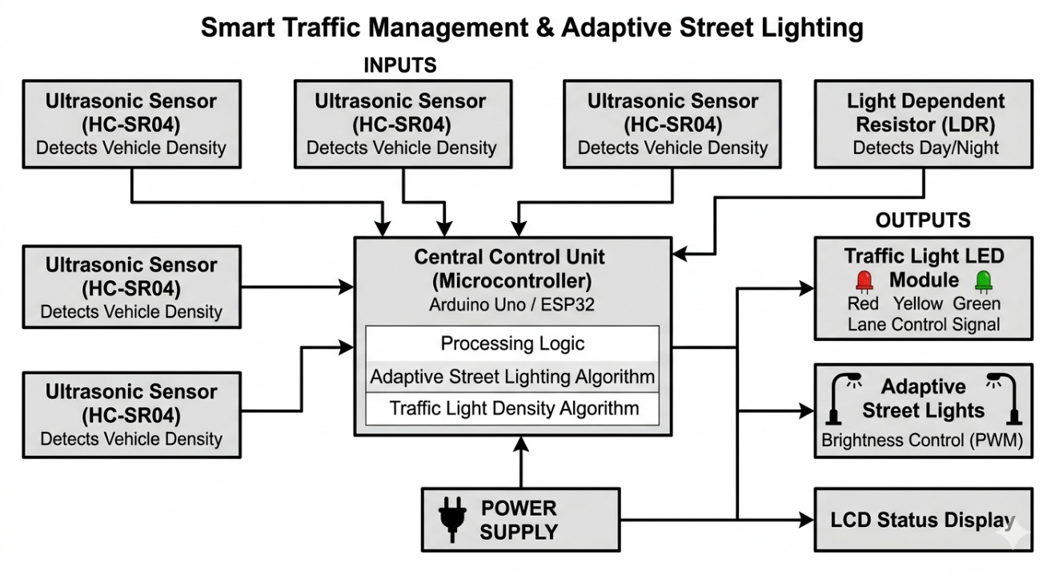
Fig 1 : Block Diagram

The block diagram consists of IR sensors and an LDR sensor as input devices connected to the Ardinuo Nano microcontroller. The IR sensors detect vehicle density on each lane and send signals to the controller. The LDR detects ambient light conditions.
The microcontroller processes these inputs and controls the output devices, which include traffic signal LEDs and street lights. Based on vehicle density, traffic lights are dynamically controlled, and based on light intensity, street lights are automatically switched ON or OFF.

Circuit Diagram
――――――――――――――――――――

Circuit Diagram:
The circuit consists of IR sensors connected to digital input pins of the Ardinuo Nano . The LDR is connected using a voltage divider circuit to an analog pin. LEDs representing traffic signals and street lights are connected to output pins through current-limiting resistors.Proper grounding and power supply connections are ensured for stable operation.

Fig 2 : Circuit Diagram

Selection Components & Calculations
――――――――――――――――――――

Selection Components & Calculations

Components:

Arduino Nano Microcontroller

IR Sensors (Vehicle Detection)

LDR Sensor (Light Detection)

LEDs

Resistors

Breadboard / PCB

Calculation:

Using Ohm’s Law:
R = (V - Vf) / I

Example:
R = (5 - 2) / 0.02 = 150 Ω

Component Specifications:
Table 1 : Specification of Components
Component | Specification/Role | Quantity
Arduino Microcontroller | Acts as the main control unit to process sensor data and control traffic lights & street lights | 1
LDR (Light Dependent Resistor) | Detects ambient light intensity for day/night detection | 1
LEDs (Red, Yellow, Green) | Used to represent traffic signals for each lane | 9-12
Resistors | Current limiting for LEDs and voltage divider for LDR | As required
Power Supply Unit | Provides regulated DC voltage (5V/12V) to the system | 1
PCB | Used for circuit assembly and connections | 1
Connecting Wires | Used for making electrical connections between components | As required

Simulation Results
――――――――――――――――――――

Simulation

The proposed smart traffic management and adaptive street lighting system was simulated using software tools such as Wokwi to verify its functional behaviour before hardware implementation. The simulation model included IR sensors for vehicle detection, an LDR sensor for ambient light sensing, an ESP32/Arduino microcontroller as the control unit, and LEDs representing traffic signals and street lights. The IR sensors were triggered manually to simulate different traffic density conditions on multiple lanes, and the corresponding response of traffic lights was observed. The microcontroller successfully adjusted signal timing by prioritizing lanes with higher vehicle density, ensuring efficient traffic flow.
In addition to traffic control, the adaptive street lighting system was tested by varying light intensity conditions in the simulation environment. The LDR sensor responded accurately to changes in light levels, switching the street lights ON during low-light (night) conditions and OFF during high-light (day) conditions. The simulation results confirmed proper coordination between sensor inputs and controller outputs, demonstrating reliable system performance and validating the design prior to physical implementation.

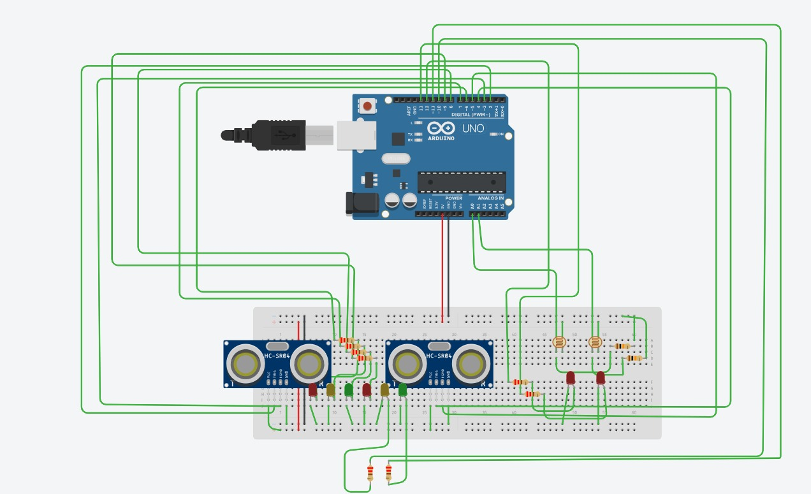
Fig 3: Simulation Image

PCB Art Work
――――――――――――――――――――

PCB Artwork

The PCB (Printed Circuit Board) artwork was designed to ensure compactness, reliability, and ease of assembly. The circuit layout was carefully planned to minimize noise, reduce signal interference, and maintain proper spacing between components.
The schematic diagram of the circuit was first converted into a PCB layout using appropriate design software. Proper routing of tracks was ensured to avoid overlapping and short circuits. Special attention was given to power and ground lines to maintain stable operation.

After finalizing the layout, the PCB was fabricated using standard techniques. Components were then mounted on the board and soldered properly to ensure strong electrical connections. The final PCB was inspected visually and electrically tested to confirm that there were no faults such as open circuits or short circuits.

Testing Procedures
――――――――――――――――――――

Testing Procedures

The testing of the smart traffic management and adaptive street lighting system was carried out in a systematic and step-by-step manner to ensure the proper functioning of each component as well as the complete integrated system. Initially, individual components such as IR sensors, LDR sensor, microcontroller (ESP32/Arduino), and LEDs were tested separately to verify their working conditions. The IR sensors were checked for accurate vehicle detection by placing objects in front of them and observing the output signals. Similarly, the LDR sensor was tested under different lighting conditions to ensure proper variation in resistance and correct response to day and night environments. The microcontroller was programmed and verified to ensure correct input-output processing.

After successful individual testing, all components were integrated according to the circuit design and tested as a complete system. Different traffic scenarios were simulated by activating IR sensors in various combinations to represent low and high vehicle density, and the corresponding traffic signal responses were observed. The system was also tested for day and night conditions by varying light intensity to verify automatic street light control. Multiple test trials were conducted to check consistency, reliability, and response time of the system. Any minor errors or delays observed during testing were corrected, and the system was retested until satisfactory and stable performance was achieved.

Enclosure Designs
――――――――――――――――――――

Enclosure Designs

The enclosure of the proposed system was designed to provide protection, safety, and an organized arrangement of all electronic components while maintaining ease of operation and maintenance. A suitable casing was selected to house the microcontroller, sensors, LEDs, and power supply securely. The design ensures that all components are firmly fixed to avoid loose connections during operation. Proper slots and openings were provided for IR sensors so that they can accurately detect vehicle movement without obstruction, and for the LDR sensor to receive ambient light directly for effective day/night detection. Adequate space was maintained between components to avoid overheating and ensure proper airflow within the enclosure.
Additionally, the enclosure was designed keeping user accessibility and system visibility in mind. External interfaces such as traffic signal LEDs and street light indicators were placed on the outer surface for clear observation of system operation. Openings were also provided for power connections and programming ports of the microcontroller, allowing easy updates and troubleshooting. The material used for the enclosure was chosen based on durability, insulation, and cost-effectiveness, such as plastic or acrylic. Overall, the enclosure enhances the structural stability, safety, and aesthetic appearance of the project while ensuring reliable performance in real-world conditions.

Test Results and Analysis
――――――――――――――――――――

Test Results and Analysis

Results Table
The following table summarizes the observations recorded under different traffic density and lighting conditions during experimentation:

Table 2 : Result and Observation Table

Traffic / Lighting Condition | Observation | Effectiveness
Low Traffic Density | Short green signal duration, smooth traffic flow with minimal waiting | Good
Moderate Traffic Density | Balanced signal timing, slight waiting observed at junction | Moderate
High Traffic Density | Increased green signal time for congested lane, reduced vehicle buildup | High ✓
Daytime (High Light Intensity) | Street lights remain OFF automatically, no unnecessary power usage | Efficient ✓
Nighttime (Low Light Intensity) | Street lights turn ON automatically, proper illumination achieved | Efficient ✓

Key Observations
• The system successfully adjusted traffic signal timing based on real-time vehicle density.
• Lanes with higher vehicle concentration were given priority, reducing congestion effectively.
• Waiting time at intersections was significantly reduced compared to fixed-timing systems.
• The LDR sensor accurately detected ambient light conditions and controlled street lighting accordingly.
• Energy consumption was reduced as street lights remained OFF during daytime.
• The system showed consistent performance under different simulated traffic scenarios.

Finding: The proposed system demonstrates that dynamic traffic signal control based on vehicle density significantly improves traffic flow efficiency, while adaptive street lighting based on ambient light conditions effectively reduces energy consumption. The integration of both systems provides an efficient and practical solution for smart city applications.

Applications
――――――――――――――――――――

Applications

- Smart City Traffic Management Systems
The proposed system can be widely implemented in smart cities to manage traffic efficiently at busy intersections. By dynamically adjusting signal timings based on real-time vehicle density, it helps reduce congestion, minimize waiting time, and improve overall traffic flow. This leads to better utilization of road infrastructure and enhances commuter experience in urban areas.

- Urban Road Intersections and Highways
At major city junctions and highways where traffic volume varies throughout the day, this system can significantly improve traffic regulation. It ensures that heavily congested lanes are given priority, thereby preventing long queues and bottlenecks. This is particularly useful during peak hours, special events, or sudden traffic surges.

- Energy-Efficient Street Lighting Systems
The adaptive street lighting feature can be applied to residential areas, highways, parking lots, and public spaces. By automatically controlling street lights based on ambient light conditions, the system reduces unnecessary energy consumption and lowers electricity costs. It also contributes to sustainable and eco-friendly urban development.

- Institutional Campuses and Industrial Areas
Large campuses such as colleges, universities, and industrial zones can benefit from this system by managing internal traffic and optimizing lighting. It ensures smooth movement of vehicles within the premises while reducing power usage in street lighting, especially in low-traffic areas.

- Emergency Traffic Handling
With further enhancement, the system can be integrated with emergency vehicle detection (such as ambulances or fire trucks). It can automatically provide a green signal path for such vehicles, ensuring faster response times and improving public safety.

- Integration with IoT-Based Monitoring Systems
The system can be integrated with IoT platforms for real-time monitoring and control of traffic and lighting infrastructure. Authorities can access data remotely, analyze traffic patterns, and make informed decisions for future planning and improvements.

Advantages
――――――――――――――――――――

Advantages

- Reduction in Traffic Congestion
The system dynamically adjusts traffic signal timing based on real-time vehicle density, ensuring that heavily congested lanes are given priority. This leads to smoother traffic flow and significantly reduces waiting time at intersections.
- Efficient Utilization of Road Infrastructure
Unlike fixed-time traffic systems, this approach optimizes signal duration according to actual demand. As a result, road capacity is utilized more effectively, preventing unnecessary delays in low-traffic lanes.
- Energy Conservation in Street Lighting
The adaptive street lighting system automatically turns OFF lights during daytime and operates only when required. This reduces unnecessary power consumption and contributes to overall energy savings.
- Reduction in Fuel Consumption and Pollution
By minimizing idle time at traffic signals, vehicles consume less fuel and emit fewer pollutants. This helps in reducing air pollution and supports environmentally sustainable urban development.
- Automation and Reduced Human Intervention
The system operates automatically using sensors and a microcontroller, eliminating the need for manual traffic control. This improves reliability and reduces dependency on human operators.
- Low Cost and Easy Implementation
The use of simple components such as IR sensors, LDR, and microcontrollers makes the system cost-effective and suitable for small-scale as well as large-scale deployment.
- Scalability for Smart City Applications
The system can be easily expanded and integrated with modern technologies such as IoT and cloud-based monitoring, making it suitable for future smart city infrastructure.

Limitations
――――――――――――――――――――

Limitations

- Limited Accuracy of Sensors
IR sensors may sometimes give inaccurate readings due to environmental factors such as dust, sunlight interference, or obstacles, which can affect system performance.
- Small-Scale Prototype Limitation
The current implementation is a prototype and may not fully represent real-world conditions such as multi-lane highways, high-speed traffic, or complex intersections.
- Lack of Emergency Vehicle Detection
The system does not prioritize emergency vehicles like ambulances or fire trucks, which is an important requirement in real-world traffic management systems.
- Dependence on Proper Calibration
Accurate functioning of the system depends on correct calibration of sensors and threshold values. Improper calibration can lead to incorrect signal timing or lighting control.
- Environmental Sensitivity of LDR
The LDR sensor may not always accurately differentiate between certain lighting conditions such as fog, shadows, or artificial light sources, affecting street light control.
- Power Supply Dependency
The system requires a stable power supply for continuous operation. Any power interruption may disrupt traffic control and lighting functions.

Future Scope
――――――――――――――――――――

Future Scope

- Integration with IoT and Cloud Monitoring
The system can be enhanced by integrating IoT technology to allow real-time monitoring and control of traffic signals and street lights through cloud platforms. This will enable remote management and data analysis.
- AI-Based Traffic Prediction and Optimization
Artificial Intelligence and Machine Learning algorithms can be used to predict traffic patterns and adjust signal timings more intelligently based on historical and real-time data.
- Emergency Vehicle Priority System
Future versions of the system can include RFID or GPS-based detection of emergency vehicles, allowing automatic clearance of traffic signals to provide a free path.
- Use of Camera-Based Vehicle Detection
Advanced image processing techniques using cameras can replace IR sensors for more accurate vehicle detection and classification, improving system reliability.
- Solar-Powered Street Lighting System
The street lighting system can be upgraded to use solar panels, making it more energy-efficient and suitable for sustainable development.
- Integration with Smart City Infrastructure
The system can be connected with centralized smart city control systems to coordinate with other urban services such as surveillance, public transport, and emergency response systems.
- Adaptive Brightness Control
Instead of simple ON/OFF control, future systems can adjust street light brightness based on traffic movement or pedestrian activity to further optimize energy usage.

Program
――――――――――――――――

Program:

#define trigA 2
#define echoA 3

#define trigB 4
#define echoB 5

#define redA 6
#define yellowA 7
#define greenA 8

#define redB 9
#define yellowB 10
#define greenB 11

// LDR pins
#define ldrA A0
#define ldrB A1

// Street light LEDs
#define lightA 12
#define lightB 13

// LDR threshold
int threshold = 750;

long getDistance(int trig, int echo) {
digitalWrite(trig, LOW);
delayMicroseconds(2);

digitalWrite(trig, HIGH);
delayMicroseconds(10);
digitalWrite(trig, LOW);

long duration = pulseIn(echo, HIGH);
long distance = duration * 0.034 / 2;

return distance;
}

void setup() {
Serial.begin(9600);

pinMode(trigA, OUTPUT); pinMode(echoA, INPUT);
pinMode(trigB, OUTPUT); pinMode(echoB, INPUT);

pinMode(redA, OUTPUT); pinMode(yellowA, OUTPUT); pinMode(greenA, OUTPUT);
pinMode(redB, OUTPUT); pinMode(yellowB, OUTPUT); pinMode(greenB, OUTPUT);

pinMode(lightA, OUTPUT);
pinMode(lightB, OUTPUT);
}

void loop() {
// -------- TRAFFIC SYSTEM --------
long distA = getDistance(trigA, echoA);
long distB = getDistance(trigB, echoB);

Serial.print("Dist A: "); Serial.print(distA);
Serial.print(" | Dist B: "); Serial.print(distB);

// -------- STREET LIGHT SYSTEM --------
int valA = analogRead(ldrA);
int valB = analogRead(ldrB);

Serial.print(" | LDR A: "); Serial.print(valA);
Serial.print(" | LDR B: "); Serial.println(valB);

// Street Light A
if (valA < threshold) {
digitalWrite(lightA, HIGH);
} else {
digitalWrite(lightA, LOW);
}

// Street Light B
if (valB < threshold) {
digitalWrite(lightB, HIGH);
} else {
digitalWrite(lightB, LOW);
}

// -------- TRAFFIC DECISION --------

// Road A has more traffic
if (distA < distB) {
digitalWrite(greenA, HIGH);
digitalWrite(redA, LOW);
digitalWrite(redB, HIGH);
digitalWrite(greenB, LOW);
delay(5000);
digitalWrite(greenA, LOW);
digitalWrite(yellowA, HIGH);
delay(2000);
digitalWrite(yellowA, LOW);
}

// Road B has more traffic
else {
digitalWrite(greenB, HIGH);
digitalWrite(redB, LOW);
digitalWrite(redA, HIGH);
digitalWrite(greenA, LOW);

delay(5000);

digitalWrite(greenB, LOW);
digitalWrite(yellowB, HIGH);
delay(2000);
digitalWrite(yellowB, LOW);
}
}

Conclusion
――――――――――――――――――――

Conclusion

This project successfully demonstrates the feasibility of implementing a smart traffic management system based on vehicle density along with adaptive street lighting using day and night detection. The designed and implemented system confirms that dynamic control of traffic signals based on real-time vehicle presence significantly improves traffic flow efficiency and reduces congestion, which is consistent with modern intelligent transportation system approaches.
The system provides an effective, energy-efficient, and automated solution compared to conventional fixed-time traffic systems and continuously operating street lights. It is particularly well-suited for urban environments, busy intersections, and areas where efficient traffic control and energy conservation are essential. The integration of sensor-based detection and microcontroller-based automation ensures reliable and practical operation without the need for continuous human intervention.
While the current prototype is limited to a small-scale implementation, the results provide a strong foundation for future enhancements and real-world deployment. Advancements in sensor technology, artificial intelligence, IoT connectivity, and smart infrastructure are expected to significantly improve the accuracy, scalability, and adaptability of such systems for larger and more complex traffic networks.

This work contributes to the development of smart city solutions by combining intelligent traffic control with energy-efficient street lighting, highlighting the potential of automation and embedded systems in improving urban infrastructure and promoting sustainable development.

References
――――――――――――――――――――

References

- Author: Priyadharshini S., Gowthamraj P., Manikandan S.
Title: Density Based Dynamic Traffic Signal Simulation Using Arduino Microcontroller
Publication: Journal of Ubiquitous Computing and Communication Technologies
Volume: 7
Issue: 1
Page No.: 73–84
Year: 2025

- Author: Dipak Kumar Ghosh et al.
Title: Design a Smart Street Lighting Controller using Arduino UNO, LDR, and IR Sensors
Publication: ResearchGate / Journal Publication
Year: 2024

- Author: Sasidevi S., Vasanthi M., et al.
Title: Intelligent Street Lighting: An IoT-Based System for Adaptive Brightness and Fault Management
Publication: Journal of IoT in Social, Mobile, Analytics, and Cloud
Volume: 6
Issue: 3
Page No.: 227–239
Year: 2024

- Author: Manjunatha S. C., Raghu S., et al.
Title: Smart Traffic Signal and Intelligent Street Light Management System Based on IoT
Publication: International Journal of Engineering Research & Technology (IJERT)
Volume: 11
Issue: 5
Year: 2023

- Author: (IEEE Conference Authors)
Title: Automatic Street Light System Using Arduino & LDR Sensor
Publication: IEEE Conference
Year: 2023

